<https://confluence.airtel.com/display/AIR/Promoter+User+Detail+API?focusedCommentId=65139815#comment-65139815>

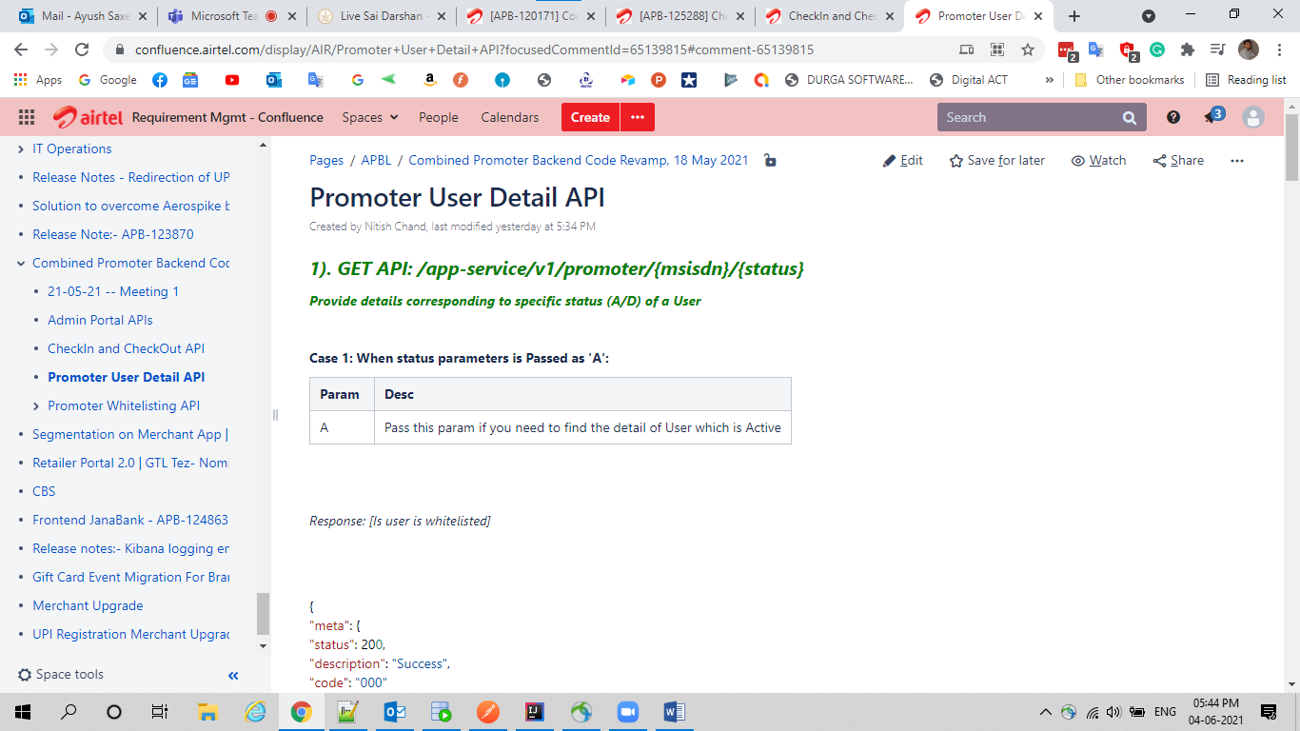

<https://confluence.airtel.com/display/AIR/LLD+Design+for+Promoter+Onboarding+through+Common+Onboarding?focusedCommentId=65139846#comment-65139846>

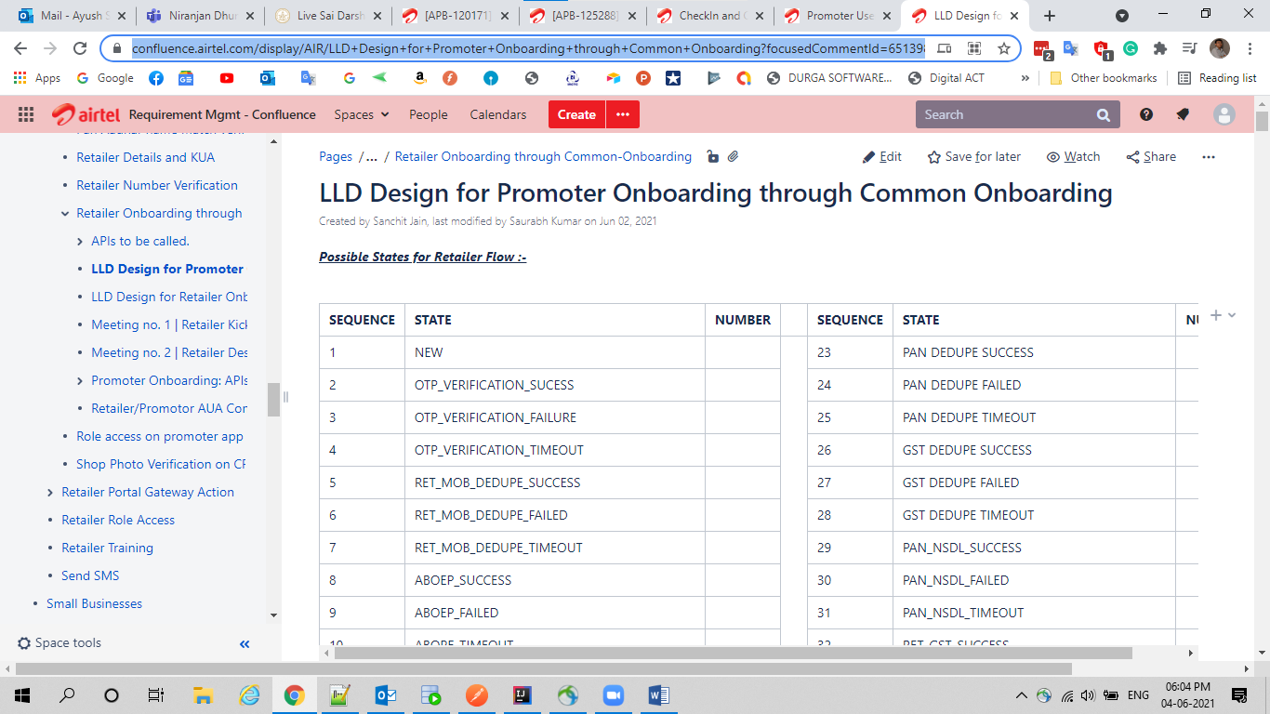

Tasks

Junit Done

API Dev Done

Document Go Through Not Done

API Up and Test Not Done

Date and Time Issue Not have information

Hi Ayush,

Use these details in the DAO changes of the Revamped APIs.

Regards,

Nitish Kumar Chand

Technology |/Users/b0222802/Library/Containers/com.microsoft.Outlook/Data/Library/Caches/Signatures/signature_1031642175

**From:** Abhishek Saxena <[a\_Abhishek.Saxena@airtelbank.com](mailto:a_Abhishek.Saxena@airtelbank.com)>  
**Date:** Wednesday, 2 June 2021 at 10:22 AM  
**To:** Nitish Chand <[nitish.chand@airtelbank.com](mailto:nitish.chand@airtelbank.com)>  
**Subject:** API response fields

Hi Nitish,

Mentioned below is the list of fields in the API response which are not being used in the UI code.

|  |  |
| --- | --- |
| user-login | firstTimeLoggedIn, promoterType, submittedEODAttendance |
| user-profile | catId, circleId,completeDate, dueDate, firstTimeLoggedIn,submittedEODAttendance,  trainingTitle,zoneId |

\*\*Most of the APIs have hardly 1-2 extra fields ( like latitude and longitude) which are present in the response but not getting used.

Please let me know if that needs to be listed as well.

Regards,

Abhishek

<https://jira.airtel.com/browse/APB-120171>

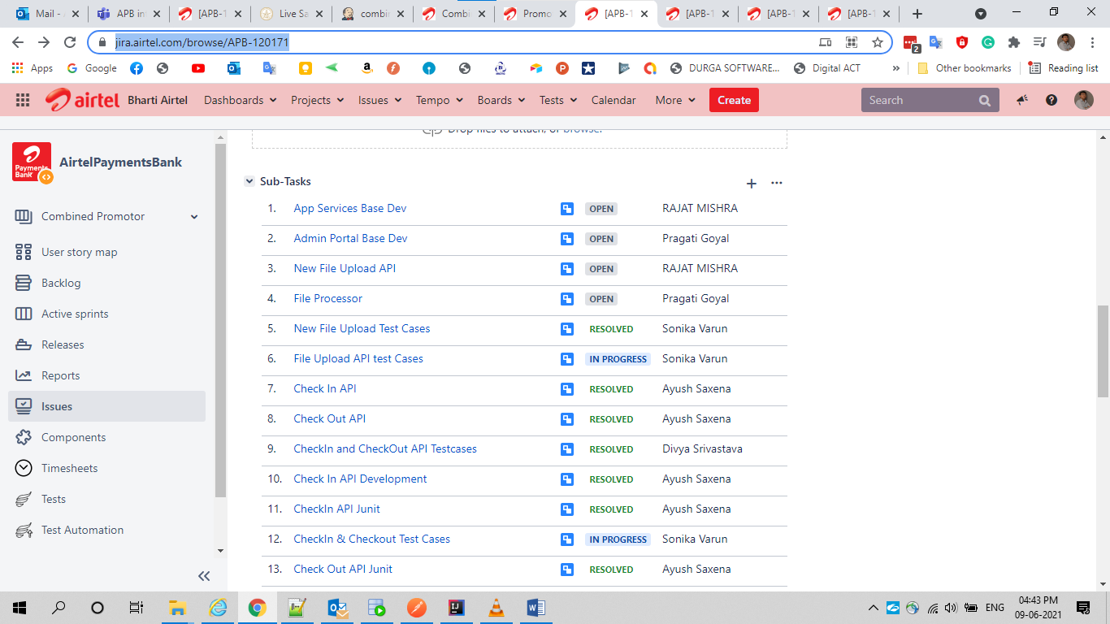

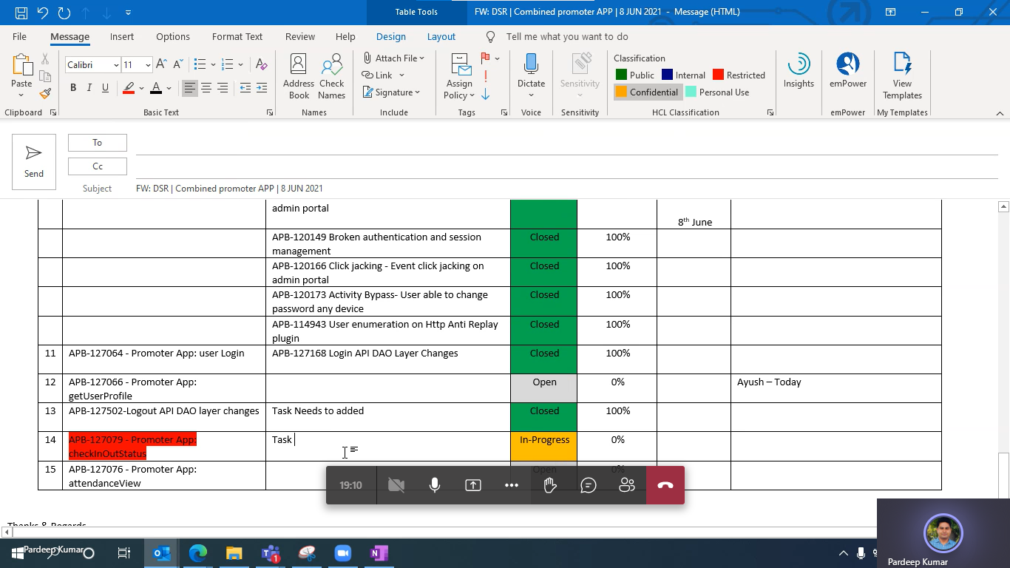

**Story**

Logout API DAO layer changes

<https://jira.airtel.com/browse/APB-127532>

**SubTask**

Logout API DAO layer changes

<https://jira.airtel.com/browse/APB-127523>

100%

**Story**

PromoterApp checkInOutStatus API DAO layer changes

<https://jira.airtel.com/browse/APB-127079>

**SubTask**

PromoterApp checkInOutStatus API DAO layer changes

<https://jira.airtel.com/browse/APB-127523>

50%

|  |  |  |  |  |  |  |
| --- | --- | --- | --- | --- | --- | --- |
| **#** | **Story** | **Tasks** | **Status** | **% Completed** | **Target Date** | **Remarks** |
| 1 | Logout API DAO layer changes  <https://jira.airtel.com/browse/APB-127532> | Logout API DAO layer changes  <https://jira.airtel.com/browse/APB-127523> | Done | 100% |  |  |
| 2 | PromoterApp checkInOutStatus API DAO layer changes  <https://jira.airtel.com/browse/APB-127079> | PromoterApp checkInOutStatus API DAO layer changes  <https://jira.airtel.com/browse/APB-127523> | In Progress | 50% |  |  |

|  |  |  |  |  |  |  |
| --- | --- | --- | --- | --- | --- | --- |
| **#** | **Story** | **Tasks** | **Status** | **% Completed** | **Target Date** | **Remarks** |
| 1 | getUserProfile  <https://jira.airtel.com/browse/APB-127066> | Promoter App: getUserProfile DAO Layer Changes  <https://jira.airtel.com/browse/APB-127864> | Done | 100% |  |  |
| 2 | AdminPortal Login  <https://jira.airtel.com/browse/APB-127036> | Admin Portal Login API DAO Layer Changes  <https://jira.airtel.com/browse/APB-127872> | In Progress | 50% |  |  |
| 3 | AdminPortal Logout  <https://jira.airtel.com/browse/APB-127050> | Admin Portal Logout API DAO Layer Changes  <https://jira.airtel.com/browse/APB-127991> | Done | 100% |  |  |